**MS- IS at Santa Clara University**

Audience: Prospective students of Santa Clara University and recruiters.

I started my search from exploration point of view. I had a wage idea that I wanted to somehow influence both prospective students and recruiters that they are putting their time, effort and resources in the right place. But I had no idea what to find and claim was an obvious confusion.  
I found a few visuals and iterated various times to get to somewhere around the idea.

**SCU Ranking:** Ranking was the first thought.  
Advantages-> Ranking gives an anchoring effect for the audience to convince.   
-> It tells about prestigious the university is.  
Disadvantage-> Although ranking tells a lot about university, it cannot be used to make a point about MS IS program specifically.

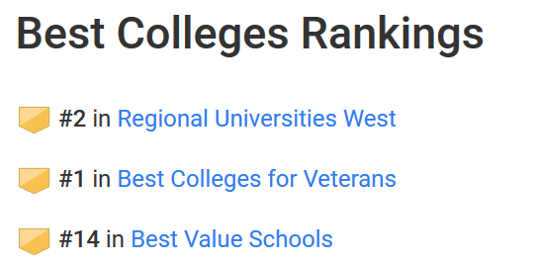

**SCU Alumni Reach:** I tried looking for accomplishments of our alumni to support my idea.  
Advantages-> We can clearly see that our alumni present is very strong among the whole world.  
Disadvantages-> Does not show why student will be convinced to take admission looking at this visual.

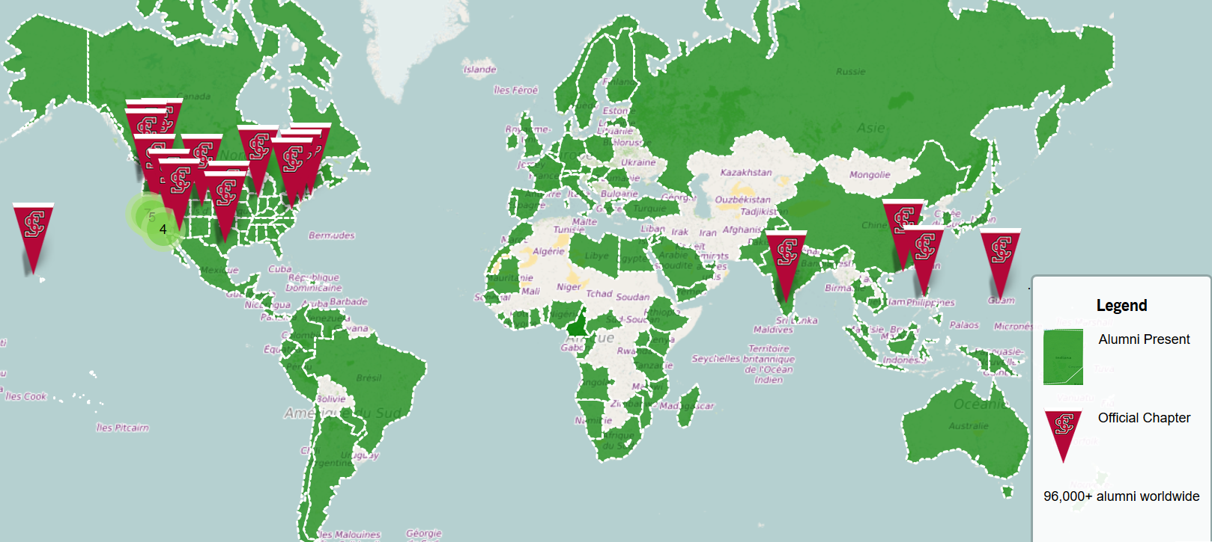

**Business Data**: Finally, I got the numbers!  
Advantage-> I was very close to what I wanted (to show accomplishments of our alumni).  
-> I got both accomplishments and mid-career pay for the university.  
Disadvantage-> It was not quite what I wanted. I wanted to show same facts but about MSIS specifically not business. So I decided not to go ahead with this data.

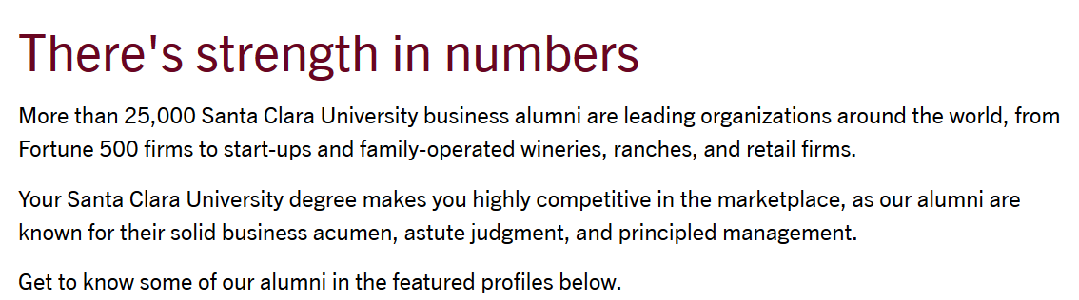

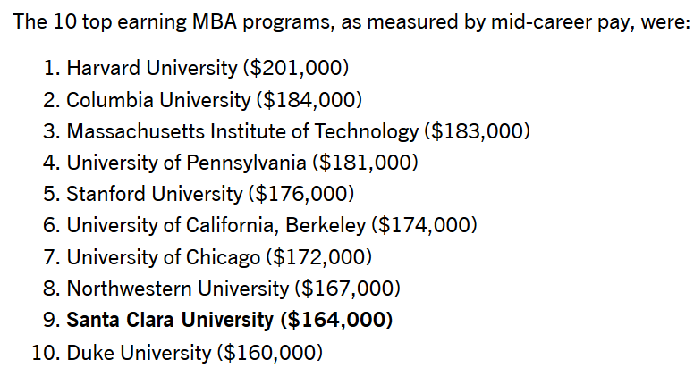

**Industry wise earnings:** Then I got to a data which took me very close to what I wanted. It was comparison of salaries of various roles.  
Advantages-> It helps to illustrate how pursuing MSIS is better than pursuing others Mater’s degree.  
Disadvantage-> I was not able to establish relationship between this data and the fact that students of particularly this university will earn this much salary.

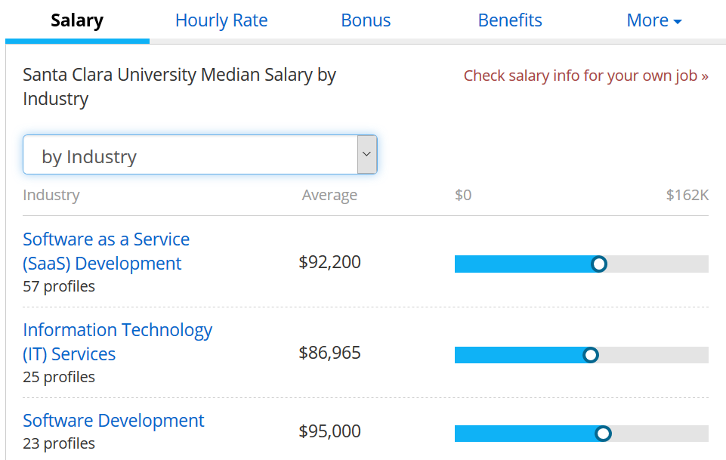

**Earnings basis on skills**: Searching through the salary averages by various components, I got to this visual which sparked the idea of my claim.   
This visual shows that how much salary you can withdraw after an MS IS program specifically if you specialize in these particular skills. I had an idea that if I could show the curriculum of MSIS provides these skills sets, it will make a very good claim about choosing Santa Clara University to study or to recruit.  
Since the data was not too large, I manually wrote the skill and average salary in an excel sheet.

**Data Source**: <https://www.payscale.com/research/US/Degree=Master_of_Science_(MS)%2C_Management_Information_Systems_(MIS)/Salary#by_Skill>

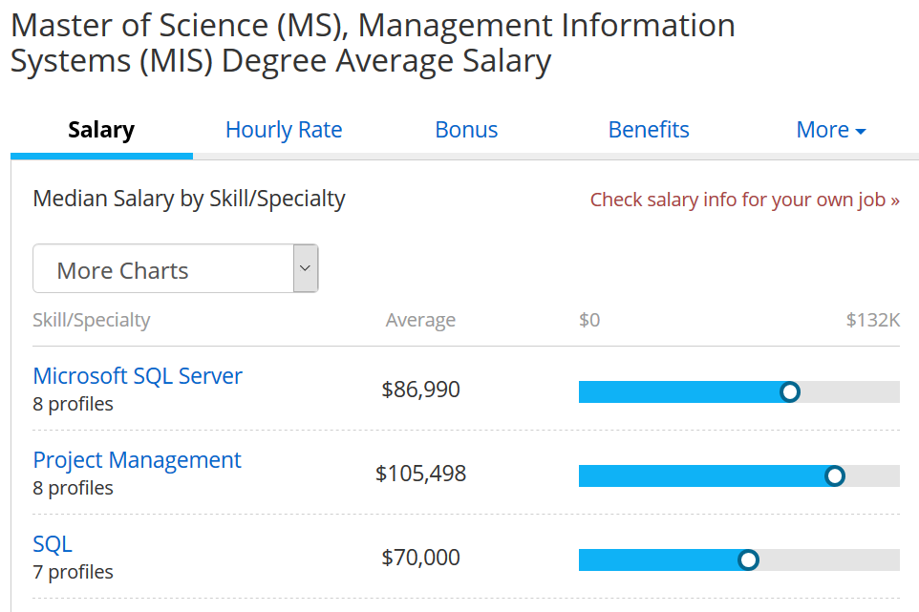

**MSIS curriculum**: Now all I wanted was to extract the curriculum from Santa Clara University’s website and combine the data from these 2 webpages.  
Advantage-> Using Beautiful Soup I extracted the data from this website.  
Disadvantage-> While scrapping the webpage I only got the course number and course name. No one knows what kind of skills these courses provide.

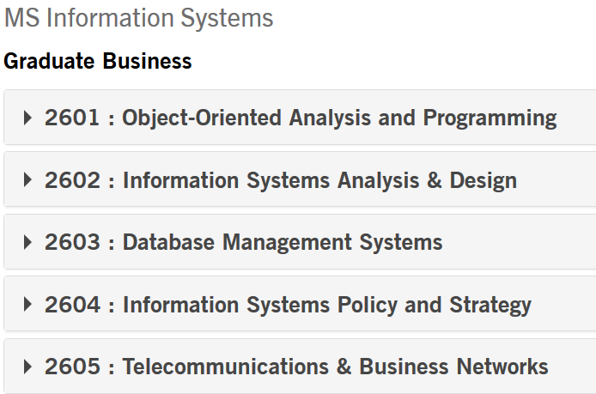

After realizing it is harder to find the data by web scarping, I turned to manually writing the data in excel sheet. I opened each subject’s description and found the skills that are provided by that subject and added it in excel.

**Data Source**: <https://www.scu.edu/business/ms-information-systems/curriculum/msis-courses/>

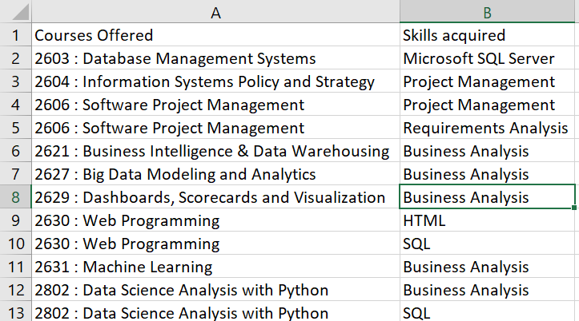

**Claim**: I support the argument- “Masters of Information System at Santa Clara University provides the skillsets required to earn good at their jobs.”

**Support**: The term ‘good’ in my claim means ‘above average’ salary in IT sector. Which is $44,148 per year for a 40-hour work week according to Bureau of Labor Statistics.

**Warrant**: <https://www.thebalance.com/average-salary-information-for-us-workers-2060808>

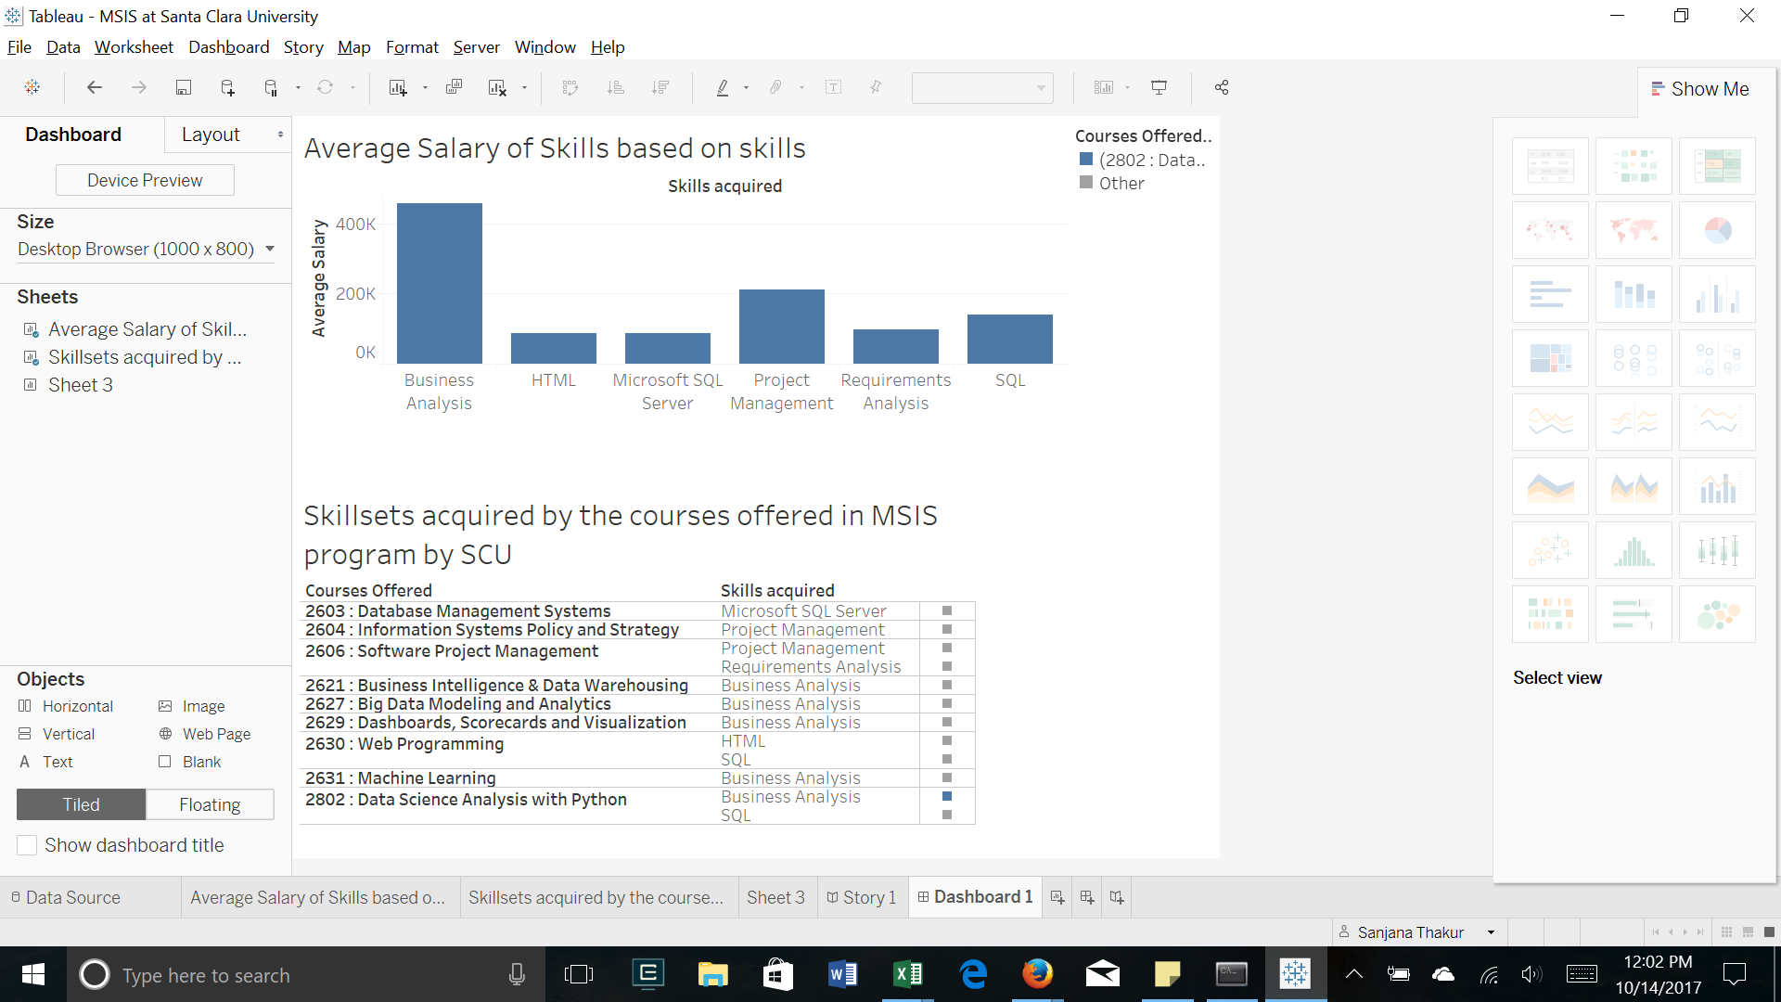

**Explanation**: The visual above explains prospective students, what kind of skillsets they will acquire if they choose Santa Clara University. They can decide based on 2 factors shown in this visualization- their interest in those skillsets and average salary earned if they specialize in one.   
On the other hand, the same visual makes it easier for recruiters to understand if these skillsets are in alignment with their requirement and what is the range of salary students would expect.